**BLUE DART DATA ANALYSIS**

**Over Viewing the data:**

SELECT * FROM Order_Details

SELECT * FROM Orders

SELECT * FROM Employee_Details

SELECT * FROM Categories

SELECT * FROM Products

SELECT * FROM Shippers

SELECT * FROM Suppliers

**KPI’s Analysis:**

1. **TOTAL REVENUE**

SELECT FORMAT(SUM(OD.QUANTITY * P.PRICE), 'C', 'EN-US') AS TOTAL_REVENUE

FROM Order_Details AS OD JOIN PRODUCTS AS P ON

OD.PRODUCTID = P.PRODUCTID

**OUTPUT:**



1. **TOTAL ORDERS**

SELECT COUNT(ORDERID) AS TOTAL_ORDERS FROM ORDER_DETAILS

**OUTPUT:**



1. **TOTAL QUANTITY**

SELECT SUM(QUANTITY) AS TOTAL_QUANTITY FROM ORDER_DETAILS

**OUTPUT:**



1. **SHOWCASING EMPLOYEES NAME, EMPLOYEES_ID, QUALIFICATION BY THEIR AGE:**

SELECT NAME, EMPLOYEEID, AGE, QUALIFICATION

FROM EMPLOYEE_DETAILS

**Output:**

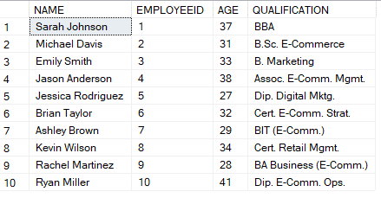

1. **SHOWCASING SHIPPERS NAME, RATE, CARRIER TYPE, SERVICE COVERAGE:**

SELECT SHIPPERSNAME, [RATES], [CARRIER TYPE], [SERVICE COVERAGE] FROM SHIPPERS

**Output:**

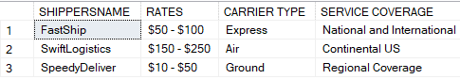

1. **VIEWING SUPPLIERS COUNT BY COUNTRY:**

SELECT COUNTRY, COUNT(SUPPLIERID) AS TOTAL_SUPPLIERS FROM SUPPLIERS GROUP BY COUNTRY

**Output:**

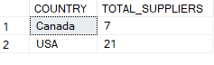

1. **REVENUE BY EACH YEAR:**

SELECT DATEPART(YEAR, O.ORDERDATE) AS YEAR,

FORMAT(SUM(OD.QUANTITY * P.PRICE),'C', 'EN-US') AS TOTAL_REVENUE

FROM ORDER_DETAILS AS OD JOIN ORDERS AS O ON OD.ORDERID = O.ORDERID

JOIN PRODUCTS AS P ON OD.PRODUCTID = P.PRODUCTID

GROUP BY DATEPART(YEAR, O.ORDERDATE)

ORDER BY YEAR

**Output:**

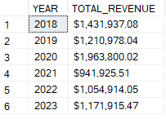

1. **REVENUE BY EACH QUARTER BY EVERY YEAR:**

SELECT YEAR,

FORMAT(SUM(CASE WHEN SQ.YEAR_QUARTER = 1 THEN SQ.TOTAL_REVENUE ELSE 0 END),'C', 'EN-US') AS Q1_REVENUE,

FORMAT(SUM(CASE WHEN SQ.YEAR_QUARTER = 2 THEN SQ.TOTAL_REVENUE ELSE 0 END),'C', 'EN-US') AS Q2_REVENUE,

FORMAT(SUM(CASE WHEN SQ.YEAR_QUARTER = 3 THEN SQ.TOTAL_REVENUE ELSE 0 END),'C', 'EN-US') AS Q3_REVENUE,

FORMAT(SUM(CASE WHEN SQ.YEAR_QUARTER = 4 THEN SQ.TOTAL_REVENUE ELSE 0 END),'C', 'EN-US') AS Q4_REVENUE

FROM(SELECT DATEPART(YEAR, O.ORDERDATE) AS YEAR,

DATEPART(QUARTER, O.ORDERDATE) AS YEAR_QUARTER,

SUM(OD.QUANTITY * P.PRICE) AS TOTAL_REVENUE

FROM ORDER_DETAILS AS OD JOIN ORDERS AS O ON OD.ORDERID = O.ORDERID

JOIN PRODUCTS AS P ON OD.PRODUCTID = P.PRODUCTID

GROUP BY DATEPART(YEAR, O.ORDERDATE),DATEPART(QUARTER, O.ORDERDATE)) AS SQ

GROUP BY SQ.YEAR

ORDER BY SQ.YEAR

**Output**

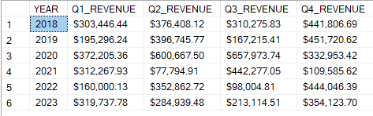

1. **TOP 5 PRODUCTS SOLD BY QUANTITY:**

SELECT TOP 5 OD.PRODUCTID, P.PRODUCTNAME, SUM(OD.QUANTITY) AS TOTAL_QUANTITY

FROM ORDER_DETAILS AS OD JOIN PRODUCTS AS P ON OD.PRODUCTID = P.PRODUCTID

GROUP BY OD.PRODUCTID, P.PRODUCTNAME

ORDER BY TOTAL_QUANTITY DESC

**Output:**

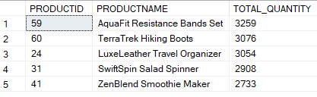

1. **BOTTOM 5 PRODUCTS SOLD BY QUANTITY:**

SELECT TOP 5 OD.PRODUCTID, P.PRODUCTNAME, SUM(OD.QUANTITY) AS TOTAL_QUANTITY

FROM ORDER_DETAILS AS OD JOIN PRODUCTS AS P ON OD.PRODUCTID = P.PRODUCTID

GROUP BY OD.PRODUCTID, P.PRODUCTNAME

ORDER BY TOTAL_QUANTITY

**Output:**

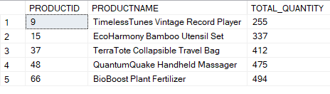

1. **5 HIGH REVENUE GENERATING PRODUCTS:**

SELECT TOP 5 OD.PRODUCTID, P.PRODUCTNAME,

FORMAT(SUM(OD.QUANTITY * P.PRICE), 'C','EN-US') AS TOTAL_REVENUE

FROM ORDER_DETAILS AS OD JOIN PRODUCTS AS P ON OD.PRODUCTID = P.PRODUCTID

GROUP BY OD.PRODUCTID, P.PRODUCTNAME

ORDER BY SUM(OD.QUANTITY* P.PRICE) DESC

**OUTPUT:**

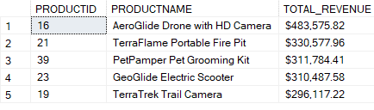

1. **5 LEAST REVENUE GENERATING PRODUCTS:**

SELECT TOP 5 OD.PRODUCTID, P.PRODUCTNAME,

FORMAT(SUM(OD.QUANTITY * P.PRICE), 'C','EN-US') AS TOTAL_REVENUE

FROM ORDER_DETAILS AS OD JOIN PRODUCTS AS P ON OD.PRODUCTID = P.PRODUCTID

GROUP BY OD.PRODUCTID, P.PRODUCTNAME

ORDER BY SUM(OD.QUANTITY* P.PRICE)

**OUTPUT:**

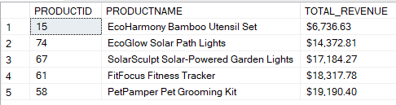

**13. 5 MOST ORDERED PRODUCTS:**

SELECT TOP 5 OD.PRODUCTID, P.PRODUCTNAME, COUNT(OD.ORDERID) AS TOTAL_ORDERS

FROM ORDER_DETAILS AS OD JOIN PRODUCTS AS P ON OD.PRODUCTID = P.PRODUCTID

GROUP BY OD.PRODUCTID, P.PRODUCTNAME

ORDER BY TOTAL_ORDERS DESC

**OUTPUT:**

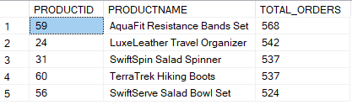

1. **5 LEAST ORDERED PRODUCTS:**

SELECT TOP 5 OD.PRODUCTID, P.PRODUCTNAME, COUNT(OD.ORDERID) AS TOTAL_ORDERS

FROM ORDER_DETAILS AS OD JOIN PRODUCTS AS P ON OD.PRODUCTID = P.PRODUCTID

GROUP BY OD.PRODUCTID, P.PRODUCTNAME

ORDER BY TOTAL_ORDERS

**OUTPUT:**

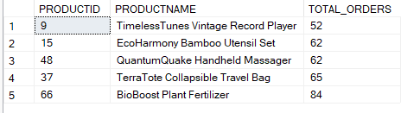

1. **SALES BY CATEGORY:**

SELECT P.CATEGORYID, C.CATEGORYNAME, COUNT(OD.ORDERID) AS TOTAL_ORDERS,

FORMAT(SUM(OD.QUANTITY * P.PRICE), 'C','EN-US') AS TOTAL_REVENUE

FROM ORDER_DETAILS AS OD JOIN PRODUCTS AS P ON OD.PRODUCTID = P.PRODUCTID

JOIN CATEGORIES AS C ON P.CATEGORYID = C.CATEGORYID

GROUP BY P.CATEGORYID, C.CATEGORYNAME

ORDER BY TOTAL_ORDERS

**OUTPUT:**

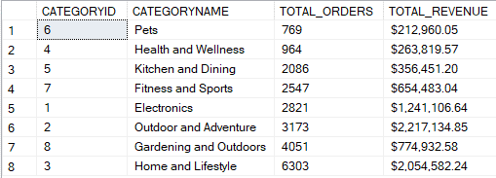

1. **MOST USED PAYMENT METHOD:**

SELECT O.[PAYMENT MODE], COUNT(O.[PAYMENT MODE]) AS NO_OF_PAYMENTS

FROM ORDER_DETAILS AS OD JOIN ORDERS AS O ON OD.ORDERID = O.ORDERID

GROUP BY O.[PAYMENT MODE]

ORDER BY NO_OF_PAYMENTS DESC

**OUTPUT:**

